Ministry of Education of the Russian Federation
The Government of Altai Territory
Shukshin Altai State University for Humanities and Pedagogy
Shukshin Memorial Museum in Srostki

Call letter
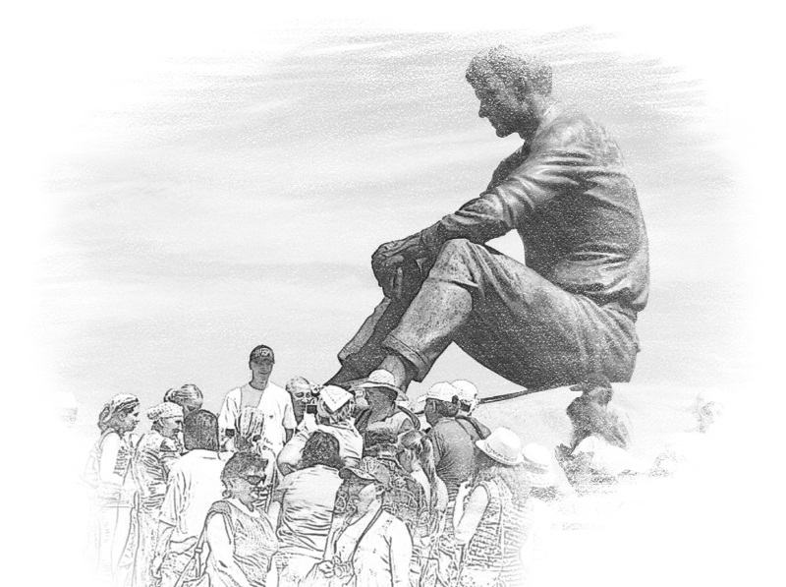
II All-Russian and International Online-Conference on Humanities
"Siberian Mentality Studies"
(in honor of Vasily Shukshin)
(SHUKSHIN-2020)
Biysk - Srostki, Altai Territory, Russia
August 24-25, 2020
Zoom-conference

Shukshin Altai State University for Humanities and Pedagogy invites researchers, lecturers, writers and literary translators to take part in the 2-^{nd} All-Russian and International Online-Conference on Humanities "Siberian Mentality Studies" (in honor of of Vasily Shukshin) which will be held in Zoom platform, on August 24-25, 2020.
Vasily Shukshin (1929-1974) was one of the unique Russian authors of village prose. But what is the actual state of the art in Russian village prose studies around the world? What are linguistic, cultural and psychological features of the prototype heroes of Russian village prose in contemporary Siberian people?
The conference aims to discuss the actual issues of Russian and Siberian mentality in philological and cultural studies, philosophy, psychology, education, history, anthropology, ethnology, cinema and arts. The conference is also aimed at introducing the culture of the contemporary Russian village to the world research and writing communities around the world.
The conference is held in the following areas (but not limited to them):
Language
Literature
Literary translation
Russian and Slavic Studies (Slavistics)
Cultural studies
Cross-cultural communication
Philosophy
Psychology
Sociology
Education
History
Anthropology
Ethnology
Cinema and arts.
Conference working languages: Russian, English.

REGISTRATION
The deadline for registration is August 10, 2020 via e-mail nio_aggpu@mail.ru
Application form
1. First name
2. Family name
3. Affiliation (Lab, Department, Institution/University, City, Country)
4. Position
5. Academic Status (PhD, Dr., Professor/Researcher/Writer/Specialist/Student/Other)
6. E-mail
7. Tel. (mobile or messenger)
8. I confirm that I am ready to take part in ZOOM online conference on August 24-25, 2020

CONFERENCE FEE
There is no conference fee to pay for accepted speakers.

ABSTRACT SUBMISSION
The deadline for abstract submission is August 21, 2020.
The abstracts should be submitted via e-mail to vlasov@bigpi.biysk.ru (for Dr Mikhail Vlasov).
The abstracts should be written in good academic Russian or English. The text must comply with the following requirements: prepared in standard A4 MS Word (doc, docx formats), up to 4 pages, in Times New Roman font, 12 pt with references. The text must include the author's name and family name, affiliation, city, country, e-mail. The abstracts include tables in the text or illustrations in JPEG format (with a resolution of at least 300 dpi).
Book of abstracts will be published in the proceedings of the conference and indexed in the Russian Science Citation Index (https://www.elibrary.ru/defaultx.asp). Open access option for authors is available and costs 800 rubles (11 $ or 10 €). The invoice for payment will be send via e-mail after abstract acceptance.
CONTACTS
Chairman of the conference:
Mikhail Vlasov, PhD in Linguistics, Associate Professor, Institute for Humanities and Pedagogy at Shukshin Altai State University for Humanities and Pedagogy (Biysk, Russia) e-mail: vlasov@bigpi.biysk.ru, vlasov_mikhailo@mail.ru
Please, contact the chairman of the conference to clarify your question.
We`ll be glad to meet you in Zoom and introduce Biysk and Srostki online!

